We will be learning about the nature of conflict by watching the blockbuster movie AVATAR. Below you will find the breakdown of this 5-day mini-unit. You will be responsible for reading articles and/or textbook material before each day. This material will be made available on my website in the AVATAR unit ahead of time if you would like to read the material more than once, or before the unit begins. You will be evaluated on Homework checks, and the material covered will be on the final exam.

 | Date | Lesson Material | Required reading before next Day
Before |  | Lesson on other class material | Chapter 21 & 22
Day 1 |  | Watch AVATAR | Solving conflict - worksheet
Day 2 |  | Homework check and take-up, Watch AVATAR.
Day 3 |  | Homework check and take-up, Watch AVATAR. | Chapter 23
Day 4 |  | Homework check and take-up, Watch AVATAR. | Just war theory - worksheet  Build a Bomb - article  Weapons and CPP - article
After |  | Homework check, lesson on other class material

Below you will find questions that can be answered while we watch AVATAR. If you can’t finish the questions during the period, they are due by the next day.

Before Day 1
- List all areas where there is a conflict currently.
- A nation state is a relatively new concept, explain what a nation state is and how it is related to sovereignty? How does the idea of the global village change national sovereignty?
- What ideology was dominant in 1976? What change occurred between 1976 and 2007 in global ideology?

Day 1
- Using terms from chapter 21, how would you describe the Na’vi race? How would you describe the immigrants from earth?
- What type of ‘power’ (pg. 352) are the humans attempting to use on the Na’vi race?
- What parallels can you come up with between previous units/course material and AVATAR?

Day 2
- How would categorize the cause(s) of the conflict between the Na’vi and the humans? (chp. 22)?
- What possible solutions to this conflict would you recommend from the group listed?

Day 3
- In chapter 22 the “costs of conflict” are outlined. What are the two costs?
- How does Eisenhower’s quote on pg. 357 relate to the conflict between the Na’vi and the humans on Pandora?

Day 4
- On page 365 Terrorism is defined. In Avatar, Colonial Quilitch speaks to his troops at the
base before they attack the Na’vi people. At one point, he says, “…we will fight
terror with terror!” Does his idea of terrorism fit with the definition on page 365? Explain.
- Why is a “War on Terror” problematic?
- What motivations for terrorism exist in the humans? What motivations for terrorism exist in the Na’vi?
- Read “How globalization can be exploited by terrorists” by James Stavridis.
  - What is the “dark side of globalization”? Give examples.
  - How do we combat this “dark side of globalization”?
  - What is meant by “there is a war of ideas”? Do you agree or disagree? Explain.

After the Movie
- Based on the “Just war theory” the first 5 principles allow one to evaluate the justice of
going to war and the 6th principle allows one to evaluate the justice in war. Accordingly, on
the basis of these principles, were the humans just in going to way? Explain why.

- Based on the 6th principle, did the Na’vi display justice in war? Explain why.
- It is possible for a just war to be fought unjustly, and an unjust war to be fought justly?
- What are the TRUE costs of war?
- Do you agree with the “possible solutions to conflict you chose on Day 3? Why or why not?

Important Vocabulary - (*) not found in the textbook
geopolitics nation state global village ideology democracy
authoritarian nationalism communism imperialism sphere of influence
conflict hard power soft power terrorism
motivations for terrorism Just war theory(*) causes of conflict
Solutions to Conflict (*)

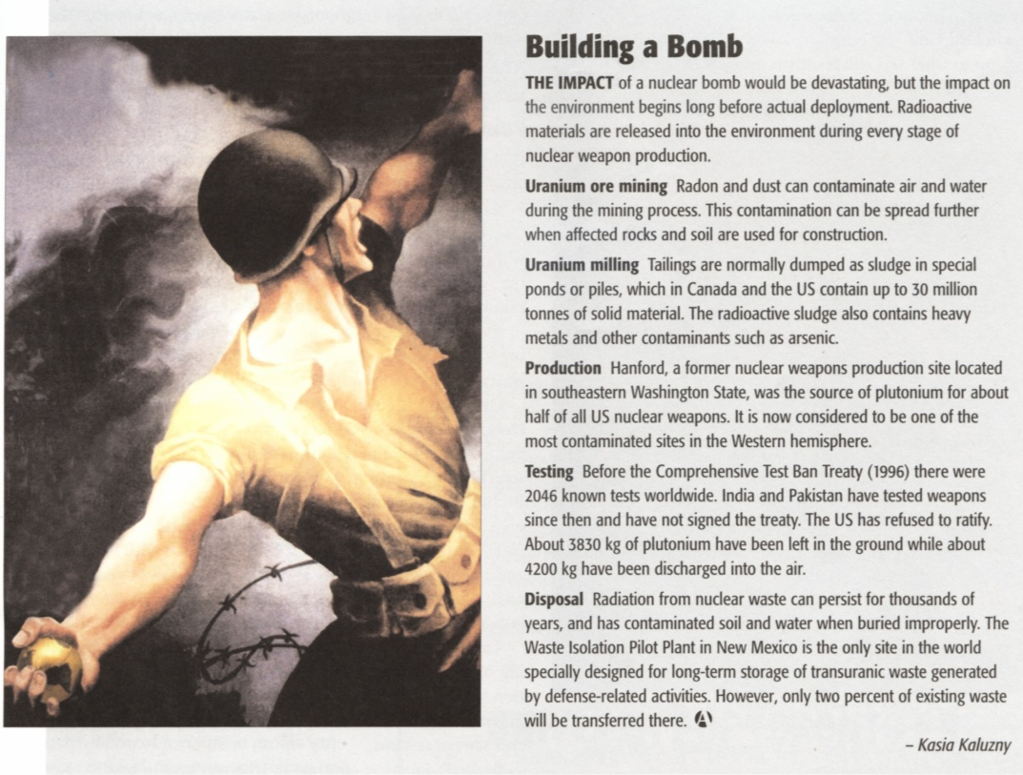

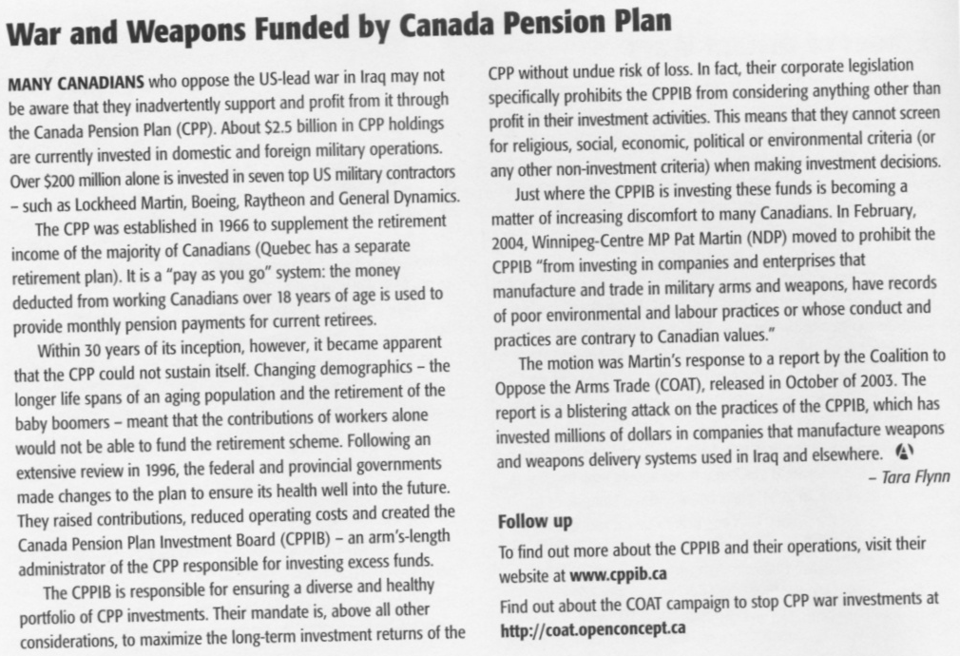

The Just War Theory
EXPLANATION OF PRINCIPLES

To be just, a war must:

- have been undertaken by a lawful authority (e.g. the leaders of the state);
- have been undertaken for a just cause, (e.g. the vindication of an infringed right);
- be undertaken as a last resort, all other peaceful means of settlement having failed;
- be waged with a reasonable hope of victory for justice;
- be waged with the right intention;
- use methods that are legitimate, i.e. in accordance with moral principles and international agreements. These are being specified as being (a) discriminate (between combatants and non-combatants) and (b) proportionate (the gains from any war are proportionate to likely losses)

Note: the first 5 principles allow one to evaluate the justice of going to war and the 6th principle allows one to evaluate the justice in war. Accordingly, on the basis of these principles, it is possible for a just war to be fought unjustly, and an unjust war to be fought justly.

Solving Conflicts


Some argue that wars and conflicts are impossible to solve because they feel that conflict is a part of human nature. What do you think?

The Nature of Conflicts Have Changed

Historically, conflicts were over political and economic expansion. Presently most conflicts are involving nationalist groups seeking political recognition. Therefore, solutions must be different than the past, when “disarmament” was the key.

- Reducing Violence – violence is everywhere (tv, video games, media, schools, locally,
internationally)
- voice our objections to violence or boycotting things that promote
violence
- Empowering Women - many traditional societies still treat women as unequal (India,
Iraq, Pakistan, Afghanistan)
- by nature, women are less aggressive ?? !! ??
- first step to this is education (if women are educated, they are
more able to make decisions about their lives)
- Reforming the UN - changing its ways to adapt to the current needs of the world
- some say expanding the security council to include
more members
- Addressing Nationalist Goals of Cultural Groups
- Most conflicts today occur within a country, not between
countries
- acceptance is the key
- Arms Reduction and Control (Military Expenditures)
- The top 6 exporters of weapons are all permanent
members of the UN Security Council (US, Russia, France,
Germany, China, UK)

